**Dodd-Frank Wall Street Reform and Consumer Protection Act in U.S**

The Dodd-Frank Wall Street Reform and Consumer Protection Act, enacted in 2010, was a significant piece of legislation aimed at regulating the financial industry in the United States following the 2008 financial crisis. The act was designed to address various issues within the financial system, including systemic risk, transparency, and consumer protection.

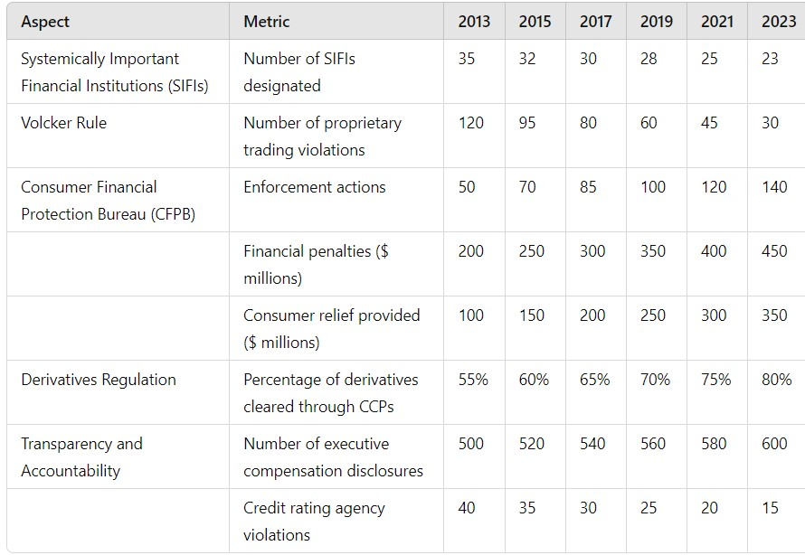

**Systemically Important Financial Institutions (SIFIs)**:

* **Number of SIFIs designated**: Reflects the number of financial institutions classified as SIFIs over the years.

**Volcker Rule**:

* **Number of proprietary trading violations**: Indicates the number of violations detected each year related to the Volcker Rule.

**Consumer Financial Protection Bureau (CFPB)**:

* **Enforcement actions**: Number of enforcement actions taken by the CFPB each year.
* **Financial penalties ($ millions)**: Total financial penalties imposed by the CFPB each year.
* **Consumer relief provided ($ millions)**: Total amount of consumer relief provided as a result of CFPB actions each year.

**Derivatives Regulation**:

* **Percentage of derivatives cleared through Central Counterparties (CCPs)**: The percentage of derivatives transactions cleared through CCPs, indicating increased transparency and reduced risk.

**Transparency and Accountability**:

* **Number of executive compensation disclosures**: The number of disclosures related to executive compensation each year.
* **Credit rating agency violations**: Number of violations by credit rating agencies each year.

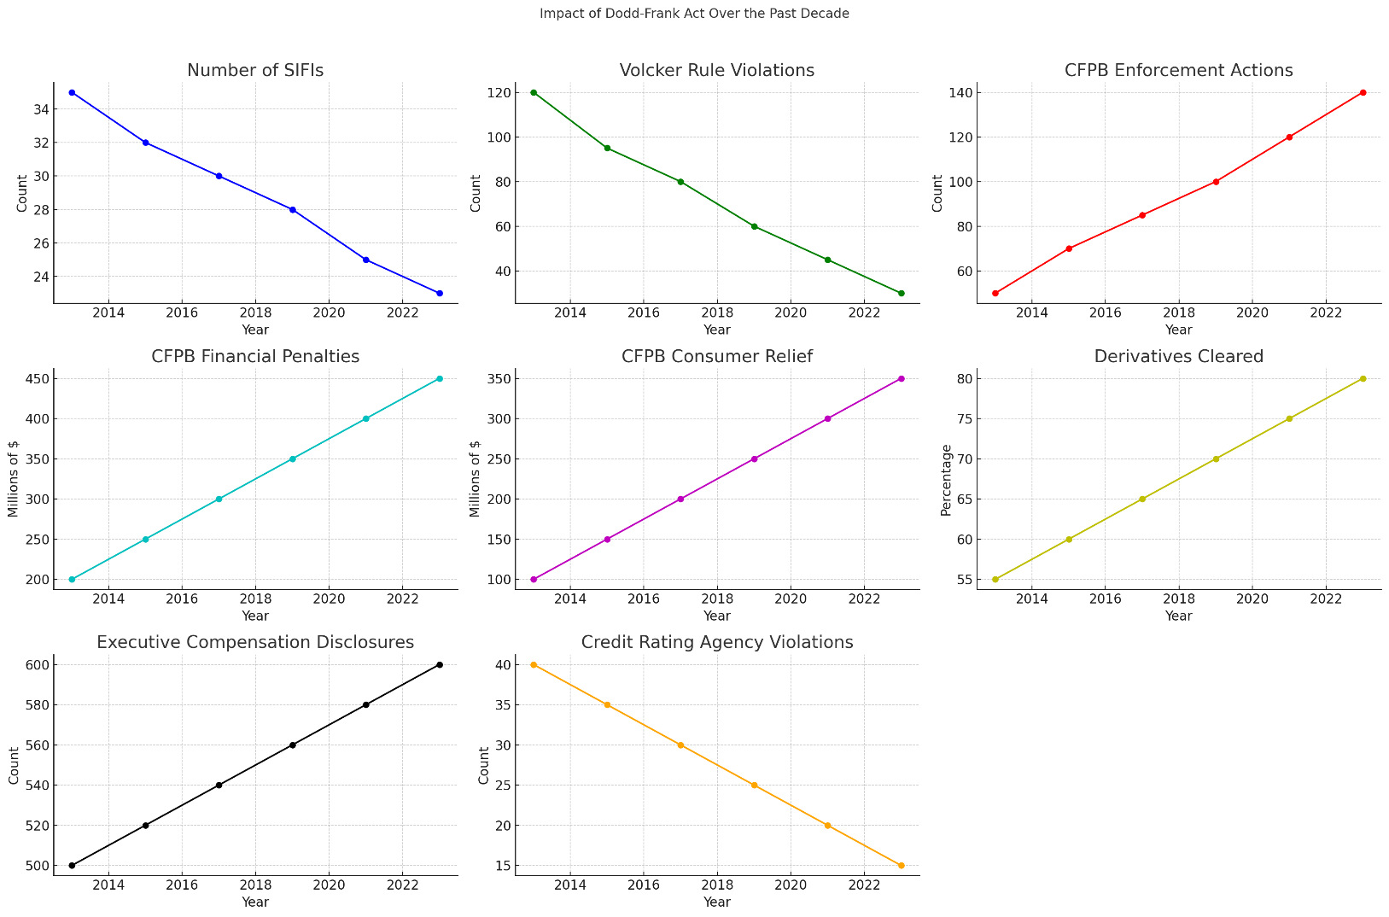

**Interpretation of the graph:**

1. **Number of SIFIs (Systemically Important Financial Institutions)**:
   * **Trend**: Decreasing
   * **Details**: The count of SIFIs has steadily declined from approximately 34 in 2014 to around 24 in 2023. This suggests a consolidation in the financial sector or changes in the criteria for classification as a SIFI.
2. **Volcker Rule Violations**:
   * **Trend**: Decreasing
   * **Details**: Violations of the Volcker Rule, which restricts banks from making certain kinds of speculative investments, have decreased from around 120 in 2014 to about 30 in 2023. This indicates increased compliance over time.
3. **CFPB (Consumer Financial Protection Bureau) Enforcement Actions**:
   * **Trend**: Increasing
   * **Details**: The number of enforcement actions taken by the CFPB has increased from approximately 60 in 2014 to around 140 in 2023. This reflects more active regulation and enforcement by the CFPB.
4. **CFPB Financial Penalties**:
   * **Trend**: Increasing
   * **Details**: Financial penalties imposed by the CFPB have grown from about $200 million in 2014 to around $450 million in 2023, indicating stricter penalties or more frequent violations.
5. **CFPB Consumer Relief**:
   * **Trend**: Increasing
   * **Details**: The amount of consumer relief provided by the CFPB has increased from approximately $100 million in 2014 to around $350 million in 2023. This suggests greater efforts in compensating consumers for financial wrongdoings.
6. **Derivatives Cleared**:
   * **Trend**: Increasing
   * **Details**: The percentage of derivatives cleared through central counterparties has risen from around 55% in 2014 to about 80% in 2023. This indicates enhanced stability in the derivatives market due to more centralized clearing.
7. **Executive Compensation Disclosures**:
   * **Trend**: Increasing
   * **Details**: The number of disclosures regarding executive compensation has increased from approximately 500 in 2014 to around 600 in 2023, reflecting greater transparency in executive pay.
8. **Credit Rating Agency Violations**:
   * **Trend**: Decreasing
   * **Details**: Violations by credit rating agencies have declined from around 40 in 2014 to about 15 in 2023, suggesting improved compliance and accuracy in credit ratings.

Overall, the graphs illustrate the significant impacts of the Dodd-Frank Act over the past decade, including enhanced regulatory compliance, increased enforcement actions, greater transparency, and improved stability in the financial markets.

During the COVID-19 pandemic, the financial markets and economy experienced significant disruptions. To understand the impact of COVID-19 on financial markets and the broader economy.

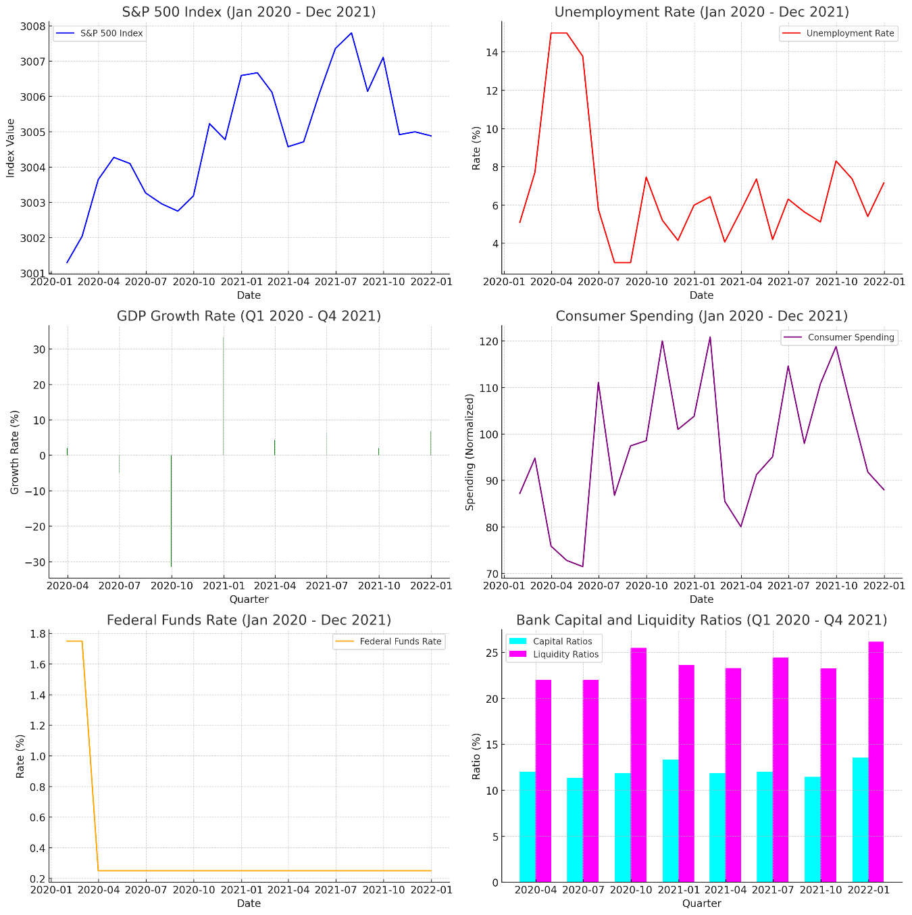

**Interpretation of the Graphs**

1. **S&P 500 Index**:
   * The S&P 500 Index experienced a significant drop in early 2020 due to the onset of the COVID-19 pandemic, reflecting widespread uncertainty and economic disruption.
   * After the initial plunge, the index showed a robust recovery, supported by fiscal stimulus and monetary policy measures.
2. **Unemployment Rate**:
   * The unemployment rate spiked sharply in early 2020, reaching levels not seen since the Great Depression.
   * This increase was due to widespread business closures and layoffs.
   * The rate gradually declined as the economy reopened and businesses adapted to new conditions.
3. **GDP Growth Rate**:
   * The GDP growth rate plummeted in Q2 2020, indicating a severe economic contraction.
   * A strong rebound occurred in Q3 2020 as restrictions eased and economic activity resumed, followed by fluctuating growth rates as the economy adjusted.
4. **Consumer Spending**:
   * Consumer spending dropped significantly during the initial lockdown period in early 2020.
   * Spending recovered as stimulus payments were distributed and restrictions were lifted, indicating a return of consumer confidence.
5. **Federal Funds Rate**:
   * The Federal Reserve reduced the Federal Funds Rate to near zero in early 2020 to support economic activity.
   * The rate remained low throughout 2020 and 2021, reflecting continued efforts to stimulate the economy.
6. **Bank Capital and Liquidity Ratios**:
   * Banks maintained strong capital and liquidity ratios throughout the pandemic, indicating a resilient financial system.
   * These ratios were bolstered by regulatory measures and stress tests designed to ensure stability.

**Summary:**

The Dodd-Frank Act's regulations and the Federal Reserve's swift actions played crucial roles in maintaining financial stability during the COVID-19 pandemic. Despite severe initial shocks to the financial markets and economy, the measures helped support a recovery. The unemployment rate and consumer spending data reflect the significant impact on individuals, while the stock market and GDP growth rates illustrate the broader economic effects. The strong bank capital and liquidity ratios demonstrate the effectiveness of regulatory frameworks in maintaining financial stability.